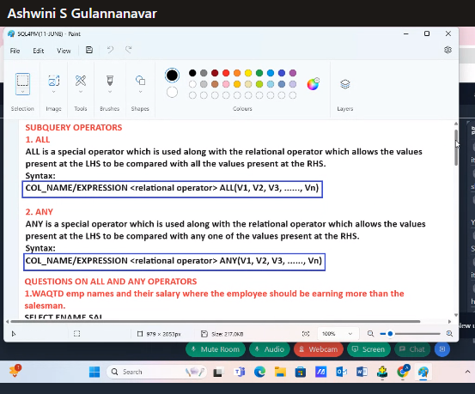

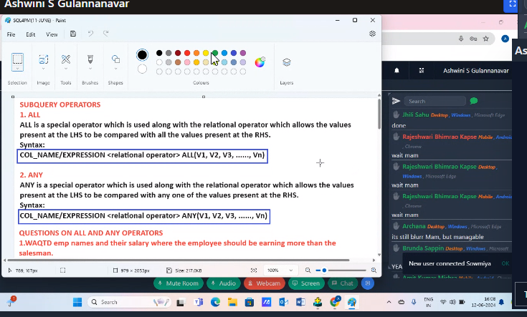

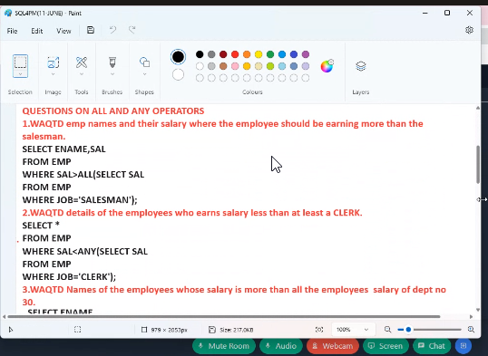

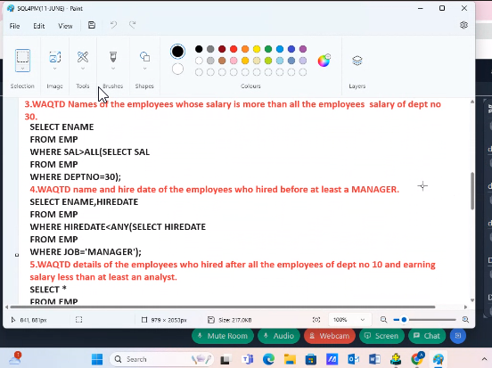

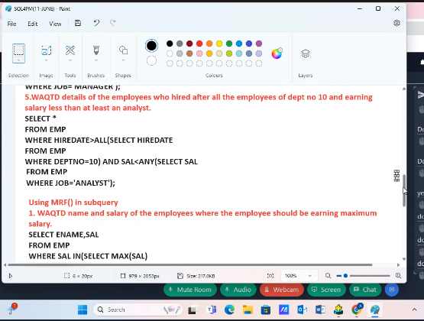

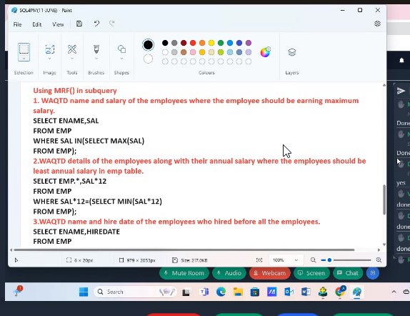

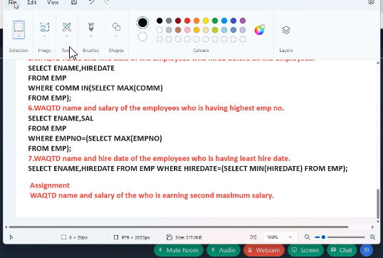

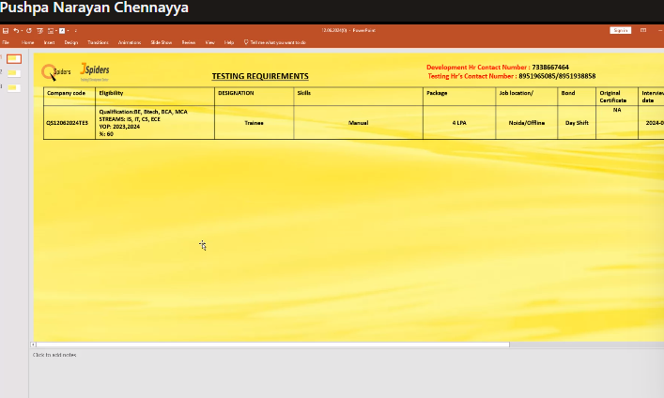

https://forms.gle/pzEFivHwAShSXVA7A *Jun 12, 4:44 PM*

https://forms.gle/o8pJv2dkqecoXVbm6 *Jun 12, 4:44 PM*

https://forms.gle/KQJr4vumKAKtSthX8 *Jun 12, 4:44 PM*

https://forms.gle/DiqvcYkaZAxqnWZu7 *Jun 12, 4:44 PM*

Subject : Manual Grooming session Trainer Name : Pooja Date : 13-06-2024 Timings : 5 - 6 pm Link : https://student.qspiders.com/classroom/QCO-GROGRD-E47 *Jun 12, 4:45 PM*

Development Hr Contact Number : 7338667464